Comparación de los modelos - Pontia Logista

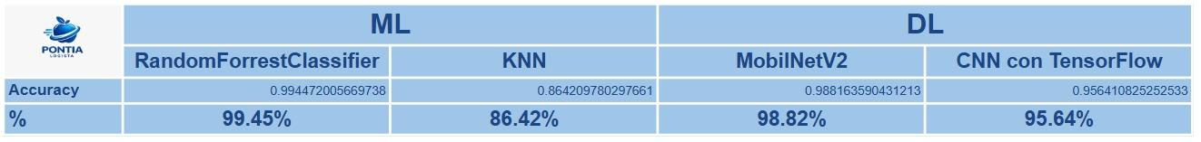

ML:

RandomForrestClassifier

Accuracy RF: 0.9944720056697378
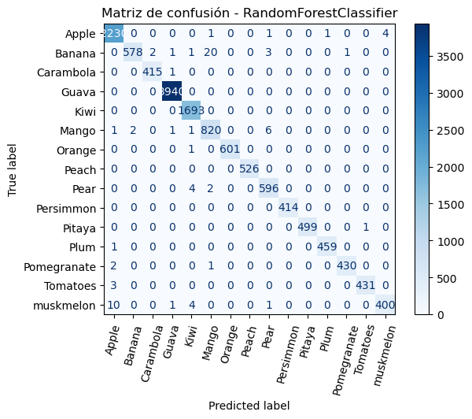
precision recall f1-score support

Apple 0.99 1.00 0.99 2237
Banana 1.00 0.95 0.97 606
Carambola 1.00 1.00 1.00 416
Guava 1.00 1.00 1.00 3940
Kiwi 0.99 1.00 1.00 1693
Mango 0.97 0.99 0.98 831
Orange 1.00 1.00 1.00 602
Peach 1.00 1.00 1.00 526
Pear 0.98 0.99 0.99 602
Persimmon 1.00 1.00 1.00 414
Pitaya 1.00 1.00 1.00 500
Plum 1.00 1.00 1.00 460
Pomegranate 1.00 0.99 1.00 433
Tomatoes 1.00 0.99 1.00 434
muskmelon 0.99 0.96 0.98 416

accuracy 0.99 14110
macro avg 0.99 0.99 0.99 14110
weighted avg 0.99 0.99 0.99 14110

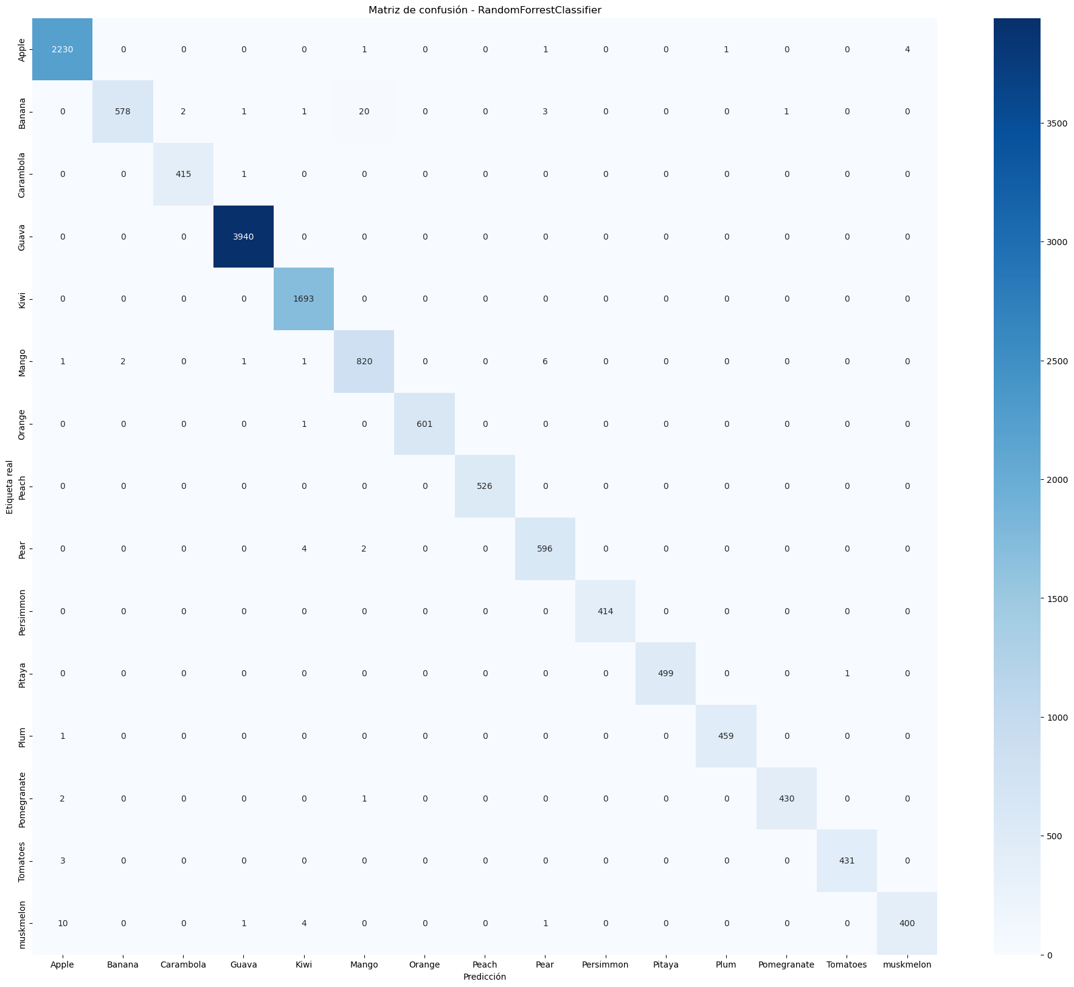
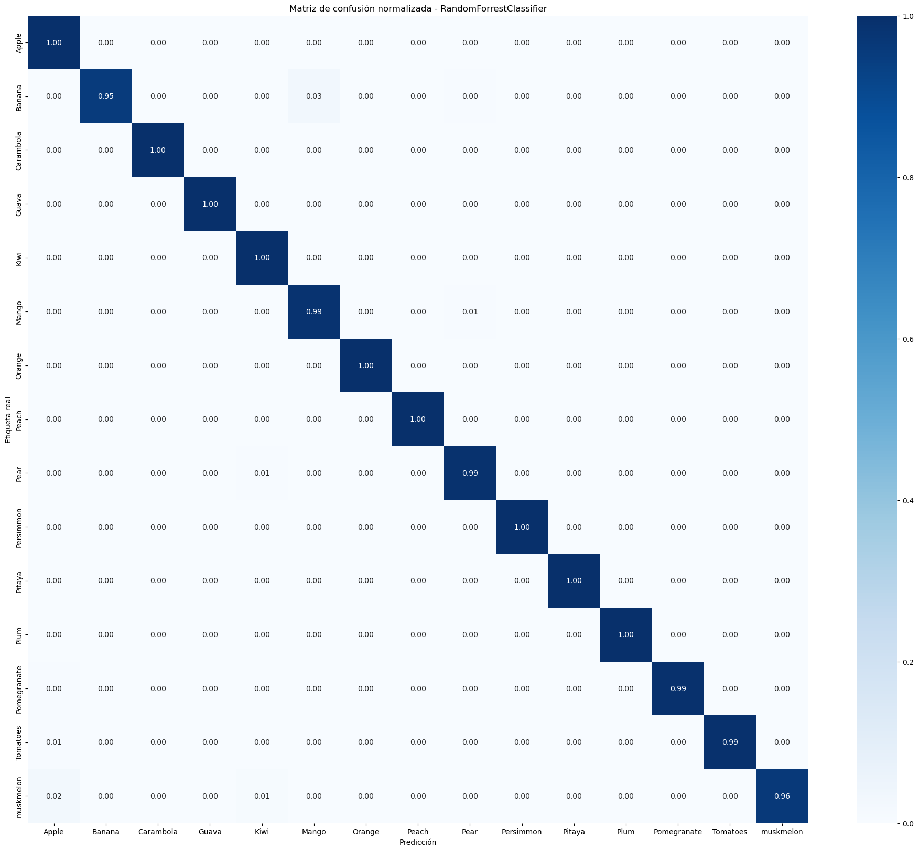
KNN:
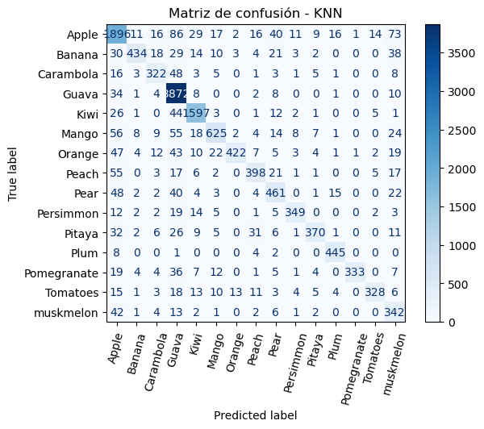
Accuracy: 0.8642097802976613

precision recall f1-score support

Apple 0.81 0.85 0.83 2237
Banana 0.92 0.72 0.80 606
Carambola 0.80 0.77 0.78 416
Guava 0.89 0.98 0.93 3940
Kiwi 0.92 0.94 0.93 1693
Mango 0.87 0.75 0.81 831
Orange 0.95 0.70 0.81 602
Peach 0.82 0.76 0.79 526
Pear 0.75 0.77 0.76 602
Persimmon 0.91 0.84 0.87 414
Pitaya 0.90 0.74 0.81 500
Plum 0.92 0.97 0.94 460
Pomegranate 0.99 0.77 0.87 433
Tomatoes 0.92 0.76 0.83 434
muskmelon 0.59 0.82 0.69 416

accuracy 0.86 14110
macro avg 0.86 0.81 0.83 14110
weighted avg 0.87 0.86 0.86 14110

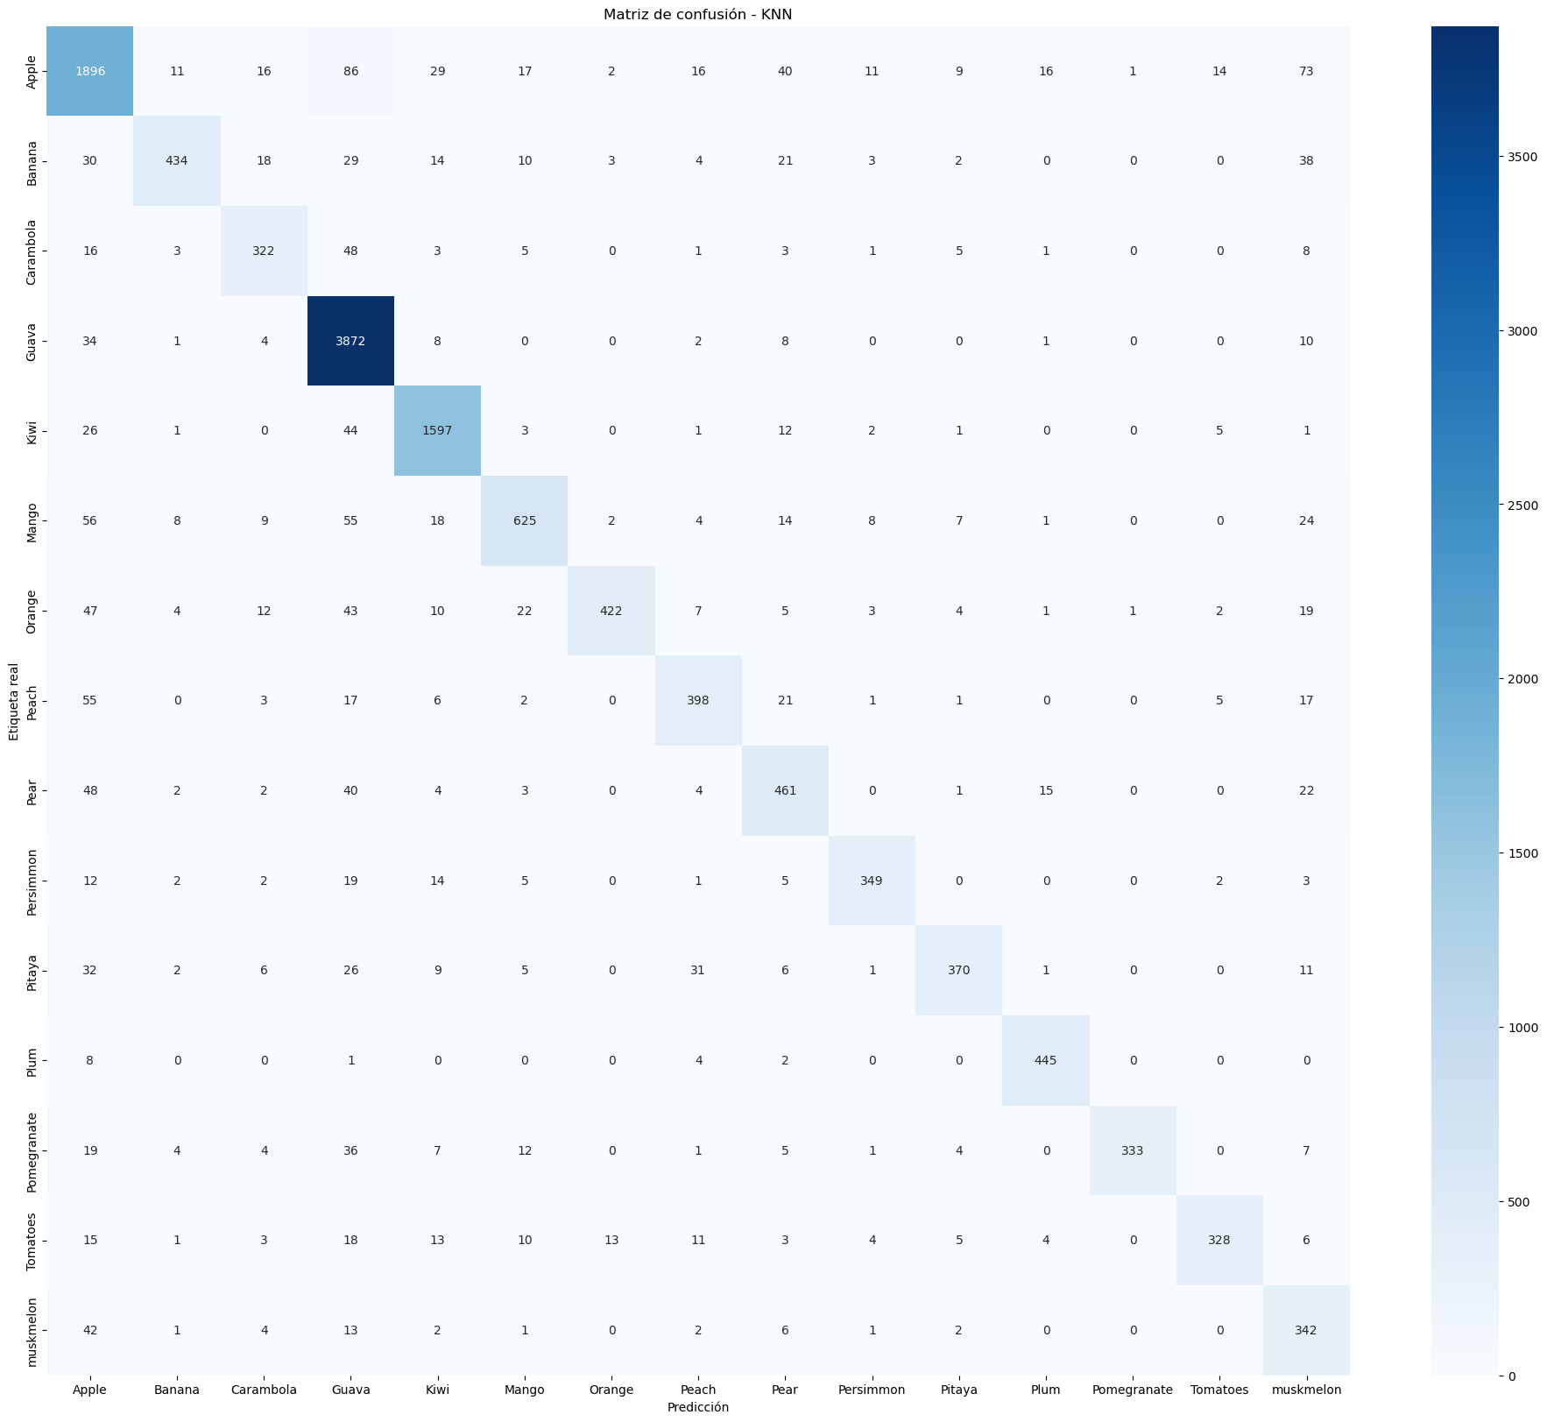
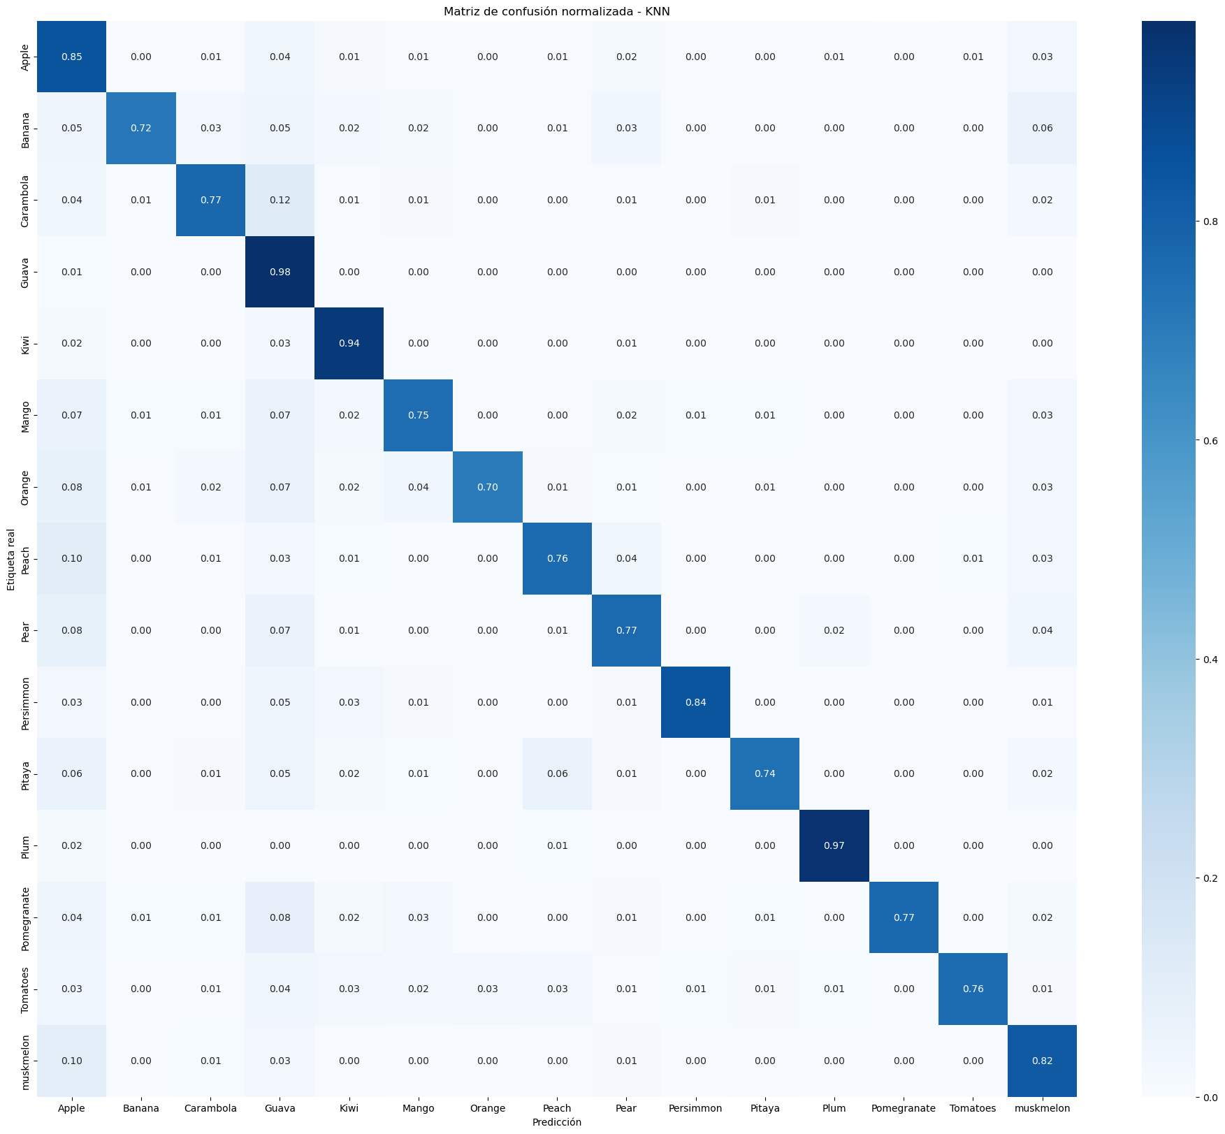
DL:

MobilNetV2

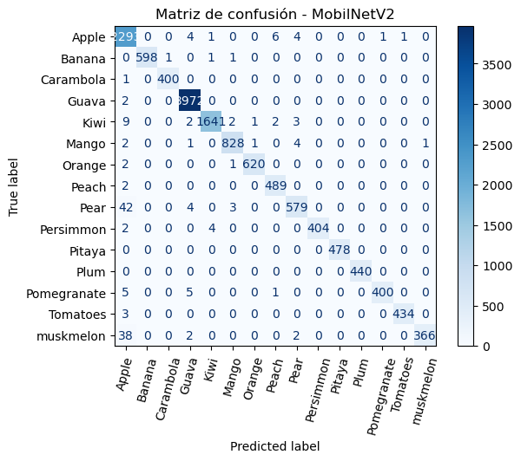
Validation accuracy: 0.9881635904312134

precision recall f1-score support

Apple 0.96 0.99 0.97 2310
Banana 1.00 1.00 1.00 601
Carambola 1.00 1.00 1.00 401
Guava 1.00 1.00 1.00 3974
Kiwi 1.00 0.99 0.99 1660
Mango 0.99 0.99 0.99 837
Orange 1.00 1.00 1.00 623
Peach 0.98 1.00 0.99 491
Pear 0.98 0.92 0.95 628
Persimmon 1.00 0.99 0.99 410
Pitaya 1.00 1.00 1.00 478
Plum 1.00 1.00 1.00 440
Pomegranate 1.00 0.97 0.99 411
Tomatoes 1.00 0.99 1.00 437
muskmelon 1.00 0.90 0.94 408

accuracy 0.99 14109
macro avg 0.99 0.98 0.99 14109
weighted avg 0.99 0.99 0.99 14109

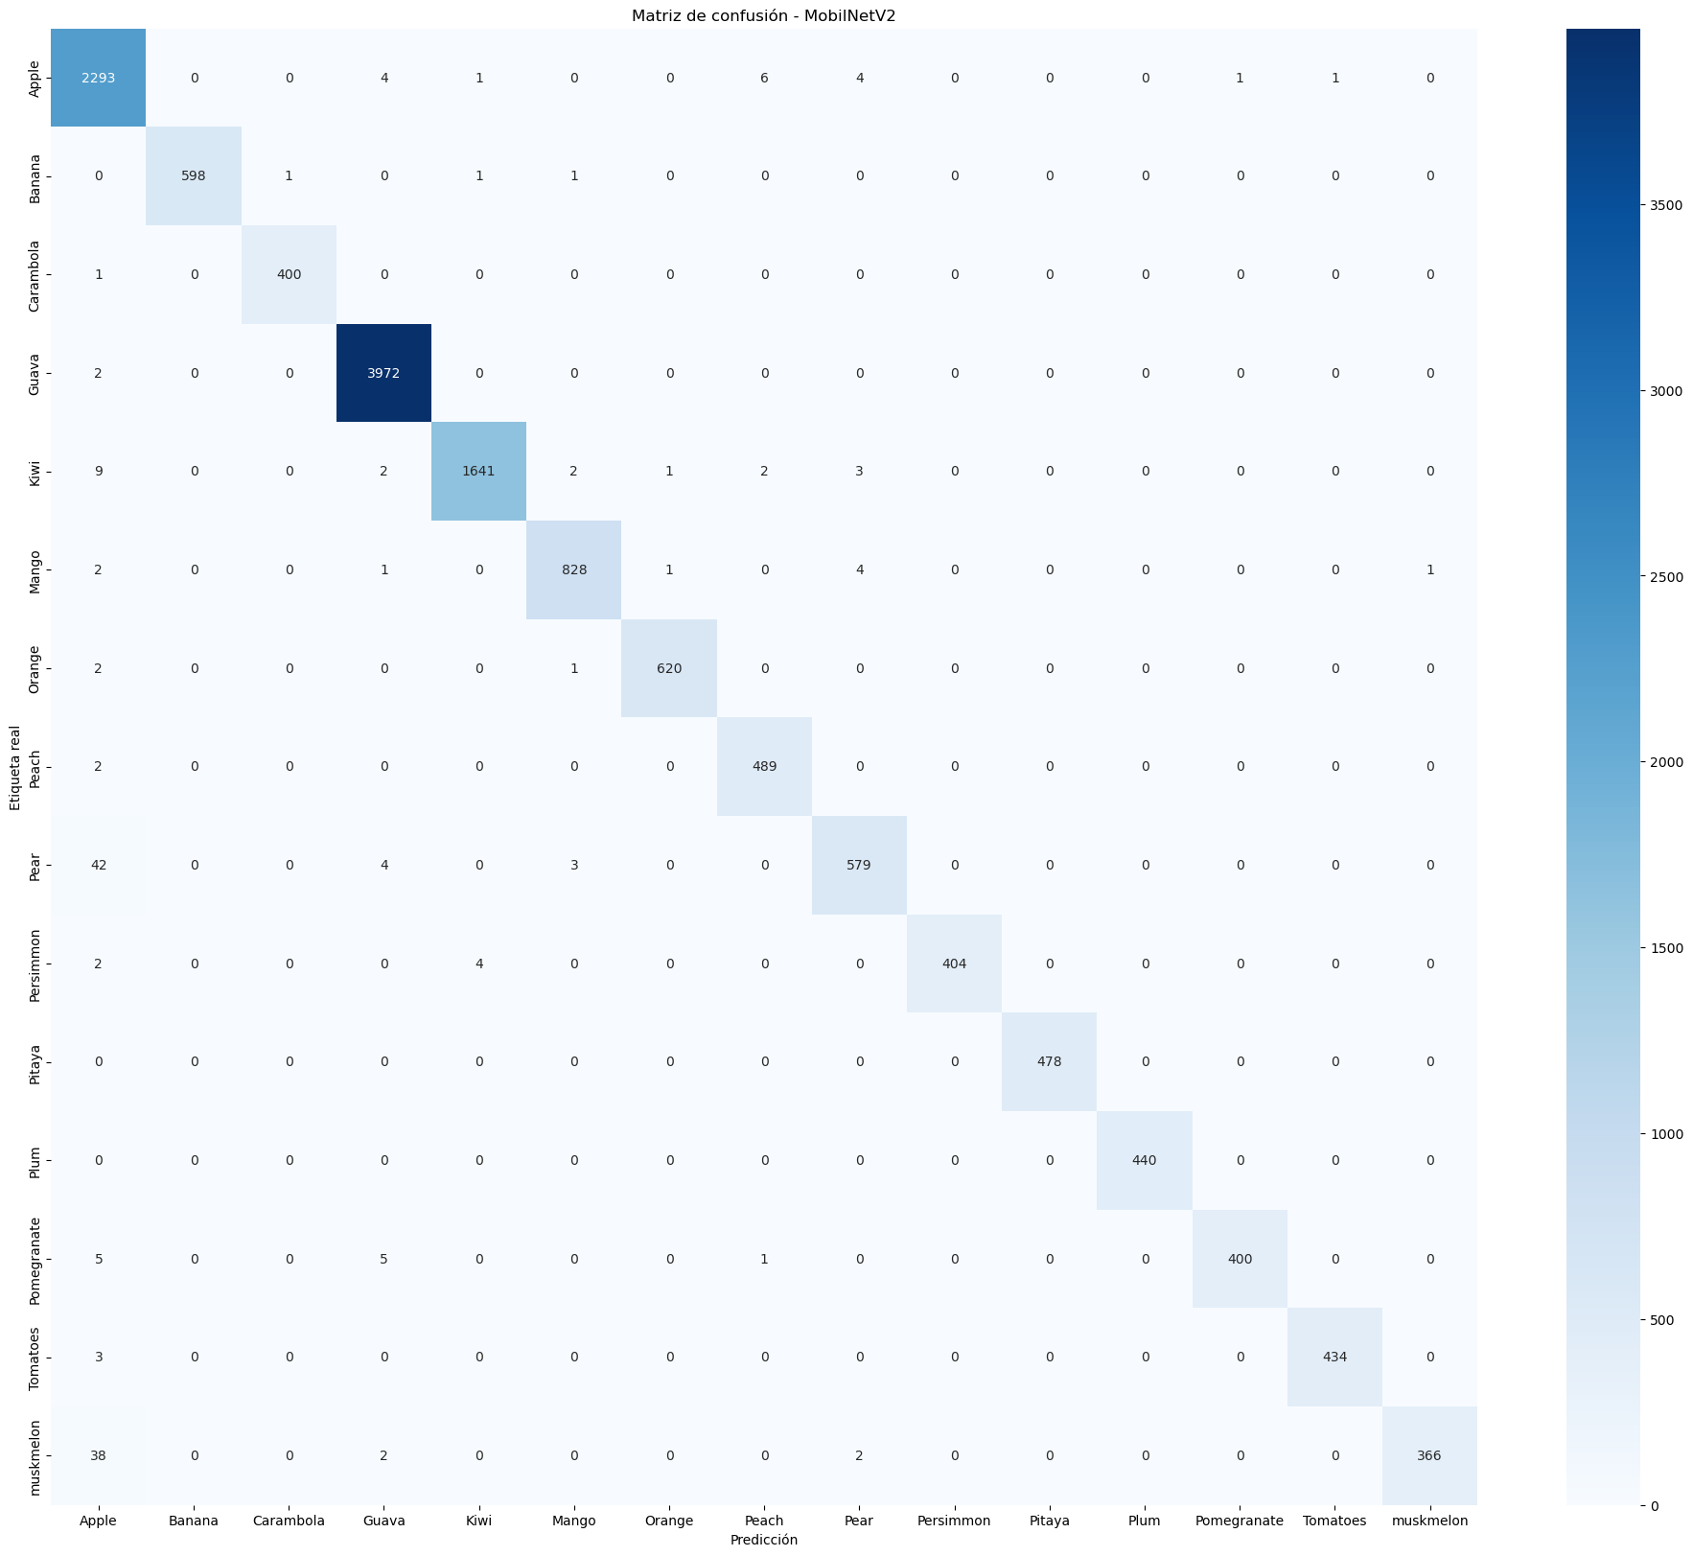
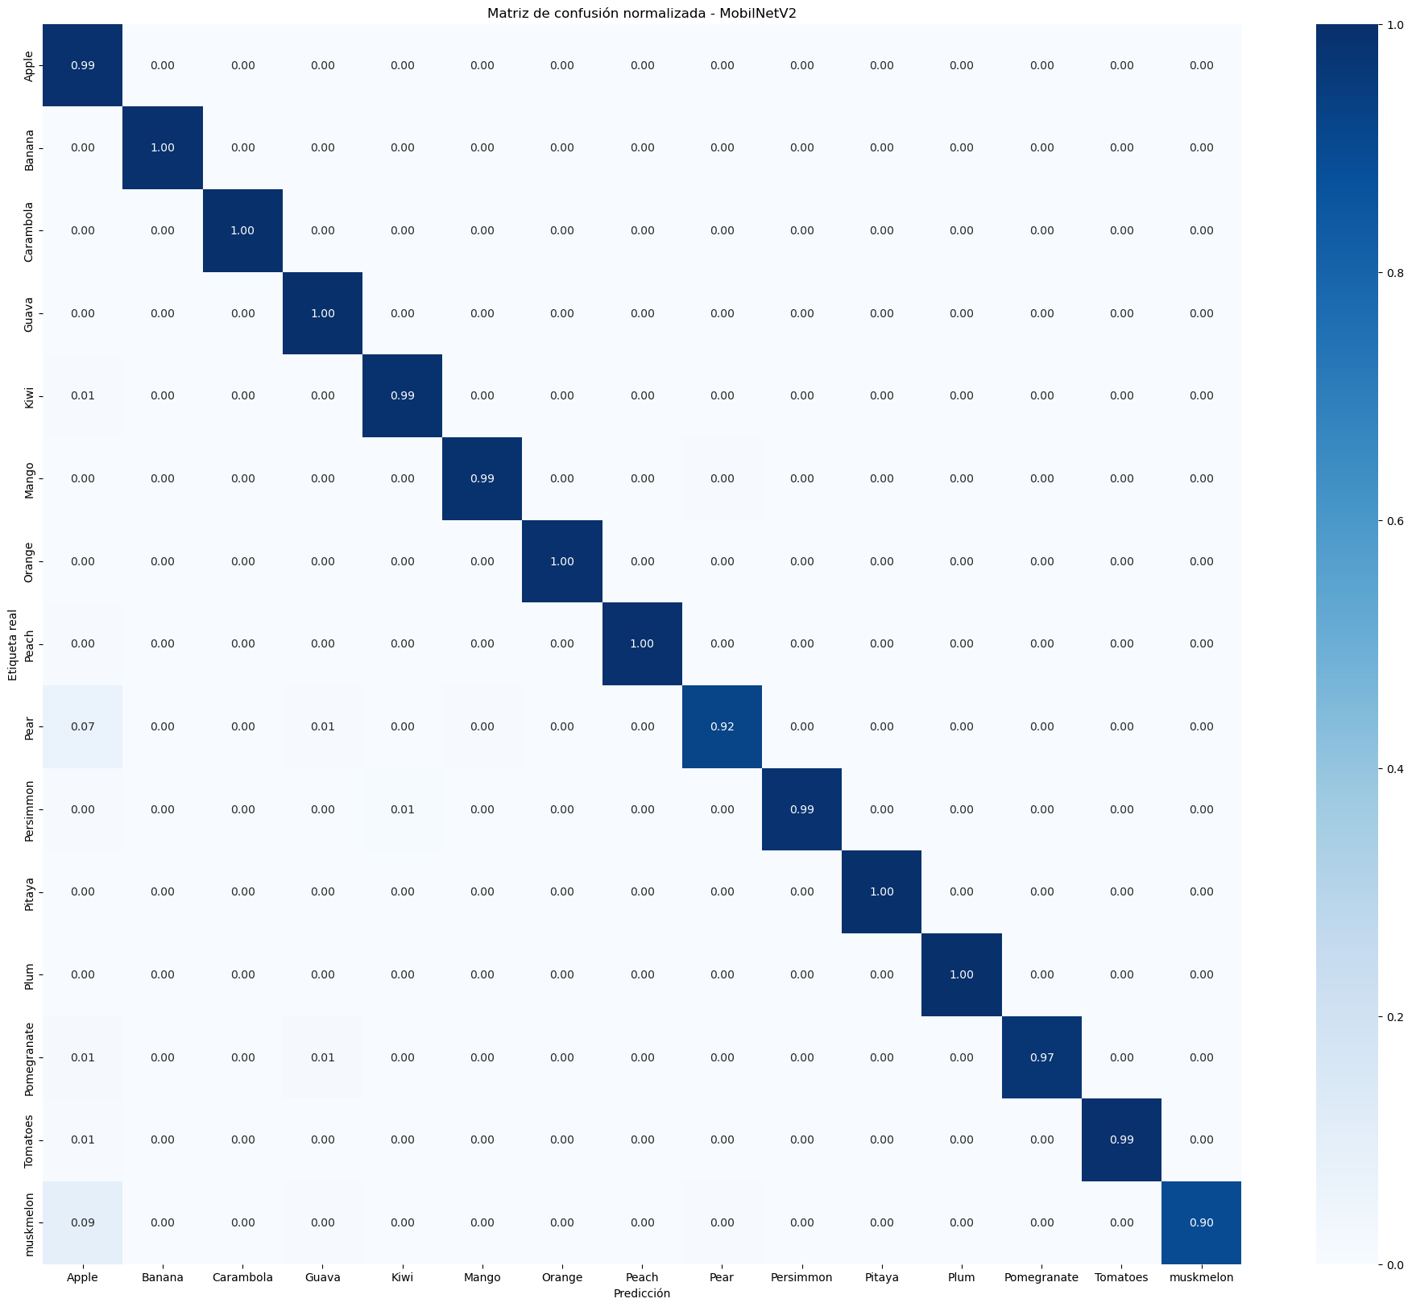
CNN_TensorFlow:
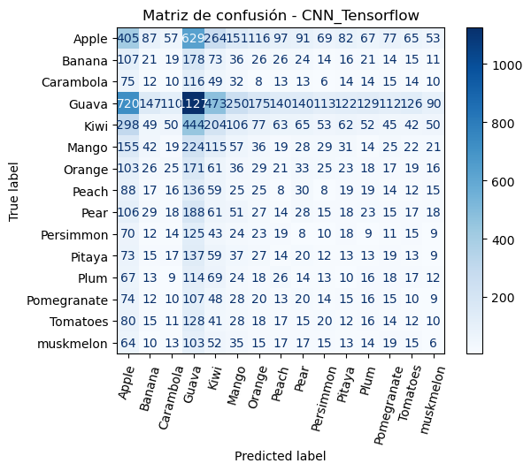
Accuracy: 0.956410825252533

precision recall f1-score support

Apple 0.16 0.18 0.17 2310
Banana 0.04 0.03 0.04 601
Carambola 0.03 0.02 0.03 401
Guava 0.29 0.28 0.29 3974
Kiwi 0.12 0.12 0.12 1660
Mango 0.06 0.07 0.06 837
Orange 0.05 0.05 0.05 623
Peach 0.02 0.02 0.02 491
Pear 0.05 0.04 0.05 628
Persimmon 0.02 0.02 0.02 410
Pitaya 0.03 0.03 0.03 478
Plum 0.04 0.04 0.04 440
Pomegranate 0.03 0.04 0.04 411
Tomatoes 0.03 0.03 0.03 437
muskmelon 0.02 0.01 0.02 408

accuracy 0.14 14109
macro avg 0.07 0.07 0.07 14109
weighted avg 0.14 0.14 0.14 14109

